**Julia Smerdel**

**MongoDB**

**Zadanie domowe**

1a)

1b)

1c)

1d)

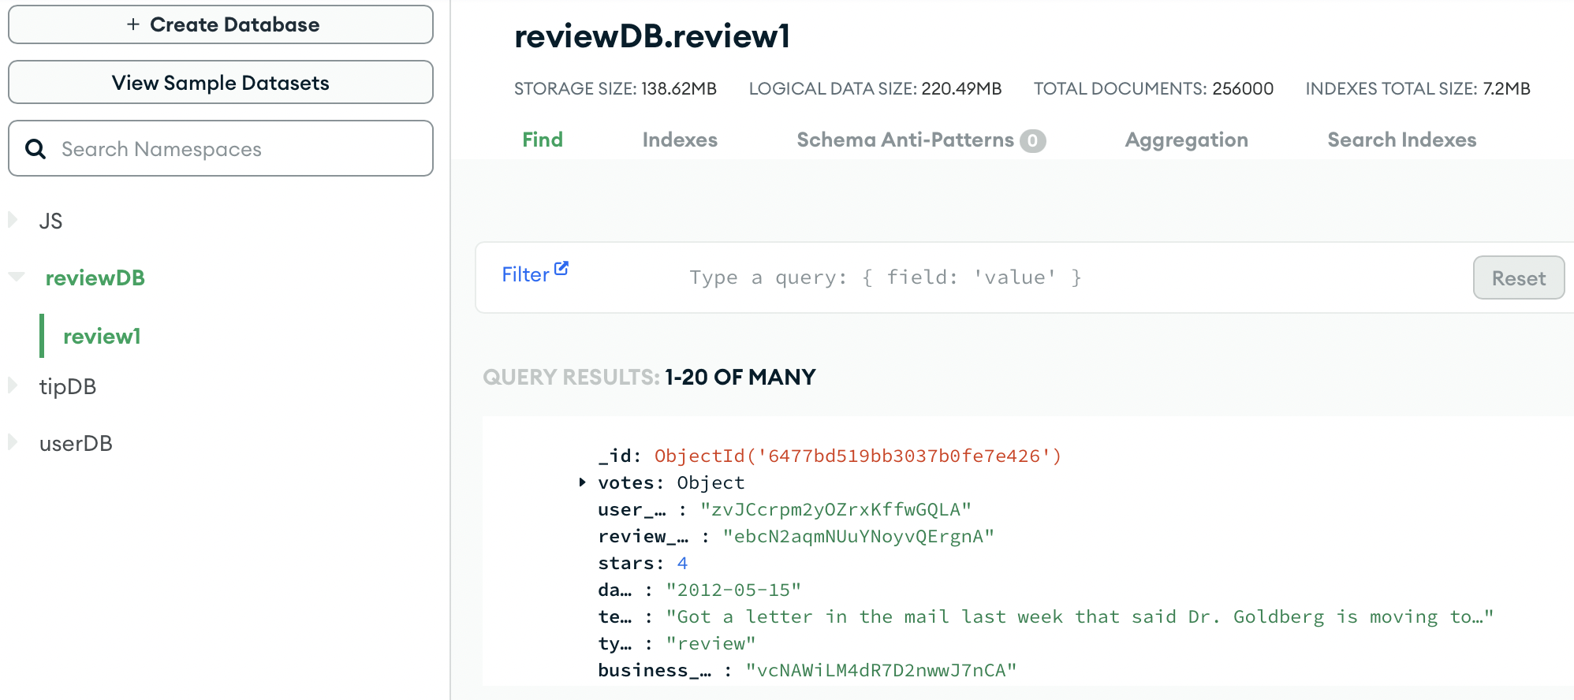

1e)

1f_1)

